

|  |
| --- |
| **MBSE drone report** |
| Drone report Engineering  Project Group 10  **Date**  07/09/2022  **Location**  Automotive campus 30, Helmond |
|  |
|  |

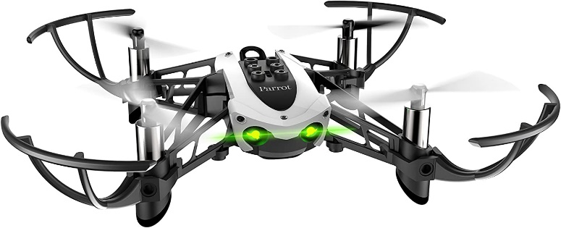



|  |  |  |  |
| --- | --- | --- | --- |
| **Revision** | **Date** | **Author** | **Description** |
| R01 | 07/09/2022 | Teun van der Aalst | Initial document (entire group) |
|  |  |  |  |

# Contact information

**Name:** Teun van der Aalst

**Function:** Project Leader

**Email:** t.vanderaalst@student.fontys.nl

**Phone:** +31 6 48084971

**Name:** Sjoerd Houwen

**Function:** Reporter

**Email:** sjoerd.houwen@student.fontys.nl

**Phone:** +31 6 83896737

**Name:** Tom Slöetjes

**Function:** Test Engineer (hardware)

**Email:** t.sloetjes@student.fontys.nl

**Phone:** +31 6 21351762

**Name:**  Beau Wilmink

**Function:** Project Manager

**Email:** b.wilmink@student.fontys.nl

**Phone:**  +31 6 55622268

**Name:** Jeedella Jeedella

**Function:** Teacher Fontys University of Applied Sciences

**Email:** j.jeedella@fontys.nl

**Phone:** +31 (0) 885078148

Table of Contents

Contact information 2

Introduction 4

Requirements 4

Assignment 4

References 5

Abbreviations

# Introduction

# Requirements

Because no specific requirements were set at the start of the project, the students thought about some requirements by themselves. In the list below the requirements for the project are enumerated.

* The drone can take-off to a specific height.
* The drone can land and shut down all 4 motors
* The drone can turn (yaw).
* The drone can fly over a specific path that is preset on forehand.
* The drone can recognize the 3 colors : Red, Green and Blue.
* The drone have some memory where coordinates can be saved.
* The drone can fly to saved coordinates.

# Assignment

With the above requirements, the students have formulated an assignment in which all these requirements are incorporated.

* The three colors are put randomly in an square area with an random orientation. The square is not bigger than 2 meters by 2 meters.
* The drone will take-off and fly a pattern where the full square is covered to find the 3 colors.
* When the drone finds a color, it will save the coordinates in the memory.
* The moment the drone is done with flying the pattern, the drone will then go to each color in order of red to green to blue.
* When the drone is above the coordinates that has been saved, the drone will turn around 360 °.
* Once it has been to the three colors, the drone will then go back to the start position and land.

# References